Important Note: The NC State Board of Education mandated that the adopted 2008 K-5 mathematics curriculum be revised using the same Essential Standards lens as A Framework For Change required of all standards. While this comes very quickly on the heels the recently adopted standards, this revision is important to ensure alignment and to build a sound, consistent mathematics program from Kindergarten through 12th grade. The big ideas in the 2008 standards are still present but may be reworded and, in some cases, moved to a different strand or grade level in these drafts. While writing these standards, the Revised Bloom's Taxonomy is being used to ensure uniformity and consistency in language and ensure the rigor of the standards.

Essential Standards • Math Grade 1

Number and Operations
1.N.1
Represent the whole numbers from 0 through 100 by counting, reading, writing, and the use of physical models.
1.N.2 Understand part-part-whole relationships and 5 and 10 as referents to compose and decompose numbers 0-100.
1.N.3 Use efficient strategies to solve a variety of story problems and generate a justification for the reasonableness of the answer.
1.N.4 Understand sharing fairly (equipartitioning) with collections of discrete items and single continuous wholes.

Algebra
1.A.1

Use models to demonstrate addition properties (commutative, associative, and identity) and the inverse relationship between addition and subtraction.
1.A.2 Apply the concept of equality.
1.A.3 Analyze repeating patterns to identify the unit, correct errors in the patterns, and extend the patterns.

Geometry
1.G.1

Classify two-dimensional figures (polygons) as parallelogram, rhombus, trapezoid and hexagon and three-dimensional figures (polyhedra) as prism and pyramid according to geometric attributes.
1.G.2 Compare geometric figures in terms of their perspectives and orientations.

Measurement
1.M.1

Use nonstandard units to estimate and measure length or weight of objects.
1.M.3 Use the names of the days of the weeks and the months of the year to describe special activities and events.

Statistics and Probability
1.S.1 Infer the rule for classifying objects on the basis of two attributes.
1.S.2 Use appropriate methods to collect, display, analyze and interpret statistical data in response to specific questions.

First Grade Number and Operations
Mathematical language and symbols that students should use and understand at this grade level:
Number, numeral (0-100), least, greatest, digit, counting by, compare, one/two more, one/two less, ten more, ten less, group, tens, ones, left over, extra, part(s), whole, double, near double, ten frame, join, separate, sum, difference, equal parts, combine, even, odd, strategy, reasonable, fact, addition, subtraction, +, -, =, number sentence, model, represent, group, collection, skip counting, correct, incorrect, true, false, add, subtract, minus
Essential Standards | Clarifying Objectives | Assessment Prototypes
1.N.1  Represent the whole numbers from 0 through 100 by counting, reading, writing, and the use of physical models. | 1.N.1.1 Understand the sequential order of the counting numbers and their relative magnitudes.  1.N.1.2 Use a range of numbers (1-10, 11-20, 21-30, etc.) to estimate the quantity of a given set.  1.N.1.3 Understand that counting by 2s, 5s, and 10s is counting groups of items by that amount.  1.N.1.4 Recognize patterns in written numerals and use those patterns to determine the order of numbers including the number before and after, 1 more and 1less, and 2 more and 2 less.  1.N.1.5 Understand that the order of the digits determines the given number and use this understanding to compare sets and numbers.  1.N.1.6 Illustrate whole numbers to 30 in groups of tens and ones using objects, pictures, and numbers. | 1.N.1 Assessment is conducted on an ongoing daily basis through observations, class discussions, and daily interactions. Please see the documentation-recording sheet to use to keep track of observations and dates of occurrence.  1.N.1.1 Materials: Number line recording sheet  Look at the number line carefully. Where would you place each of these number tiles along the number line? Explain your thinking.  Student Work Sample  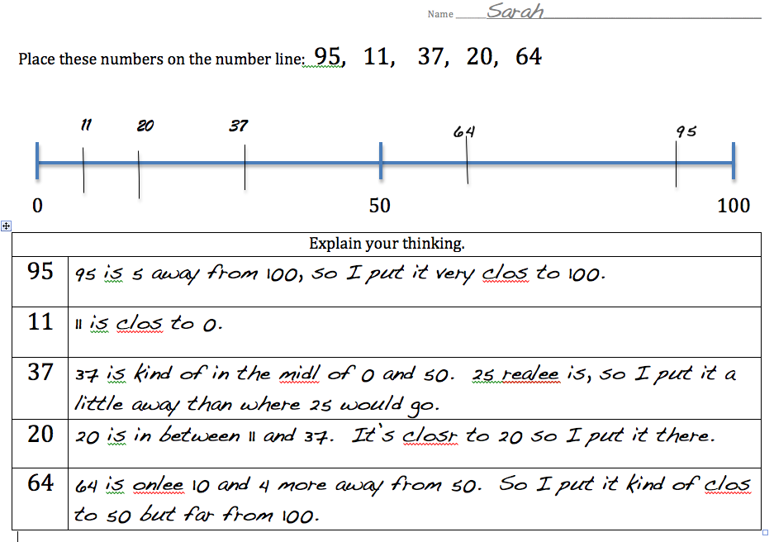  (constructed response)  1.N.1.1 Use the number line to compare these two numbers (14 and 19) in three different ways.  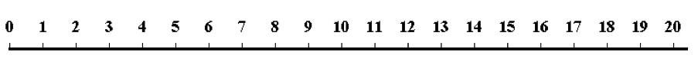  Possible responses: “14 is less than 19. 19 is 5 more than 14. 19 is closer to 20 than 14.” Or “14 is 5 less than 19. 19 is 5 more than 14. 14 is 14 jumps from 0 while 19 is 19 jumps from zero.”  (performance task)  1.N.1.1 What number should go in the box. How do you know?  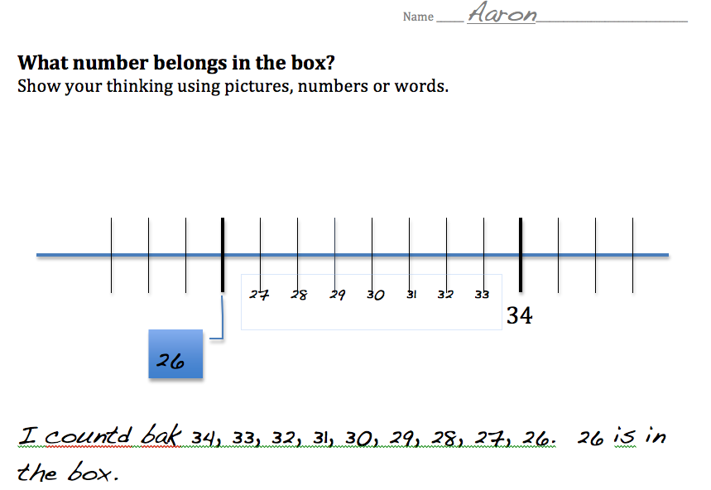  (constructed response)  1.N.1.2 Materials: ziploc bag of 39 pennies  I have a bag of pennies. How many pennies do you think there are? Do you think that there are 1-10 pennies? 11-20? 21-30? 31-40? 42-50? Why?  Possible responses: I think that there are a lot of pennies. So, I definitely think that it’s more than 10 and more than 20. I don’t think that it’s enough to make 50, so I think that there are somewhere between 31 and 40 pennies.  (performance task)  1.N.1.3 Materials: 10 counters  If I wanted to count these counters by 2s, how would I group them? How many would I have? What if I wanted to count them by 5s, how would I group them? Would I still have 10 or a different amount? Why?  (performance task)  1.N.1.4 Materials: 100s board, crayon, pencil  Color numbers on the 100s board that show a pattern using “9” by coloring every square that contains the numeral 9. What do you notice? Would the same pattern happen if you showed a pattern using “8”? Why? Why not?  (performance task)  1.N.1.4 What number comes after (36, 45, 92)? How do you know?  Possible responses: “37 comes after 36 because it goes 36, 37 like when you count 6, 7.”  (performance task)  1.N.1.4 Materials: 8 number tiles (11, 97, 51, 49, 21, 12, 78)  Arrange these number tiles from least to greatest.  (performance task)  1.N.1.4 What’s two more than 5? What’s two less than 5?  What’s two more than 25? What’s two less than 25?  What’s two more than 75? What’s two less than 75?  (constructed response)  1.N.1.5 Materials: ten-stacks, singles, numerals 53 and 35  What is the difference between these two numbers: 53 35? Use the ten-stacks to show me what you’re thinking.  “Responses could include, “Well… one is 53 and one is 35. They have the same digits, but they are in different places.” Or “53 is 5 of these ten stacks and 3 left overs and 35 is 3 of these ten stacks and 5 left over. See, just by looking you can see that 53 is more.”  (performance task)  1.N.1.6 Materials: 30 interlocking cubes  Make a pile of 23 cubes. If you were to hook the cubes together to make groups of ten, how many groups of ten do you think you would have? Would you have any leftover? How many?  Go ahead and put these cubes into groups of 10. What did you find out?  You have 2 groups of ten and 3 left over. How many cubes do you have in all? How do you know?  (performance task)  1.N.1.6 Materials: Group It Recording Sheet, pencil, crayons  Color some of the stacks of ten and some of the single cubes.  How many cubes did you color?  Now draw a different way to make the same number. How many stacks of ten did you draw? How many ones did you draw?  Student Work Example  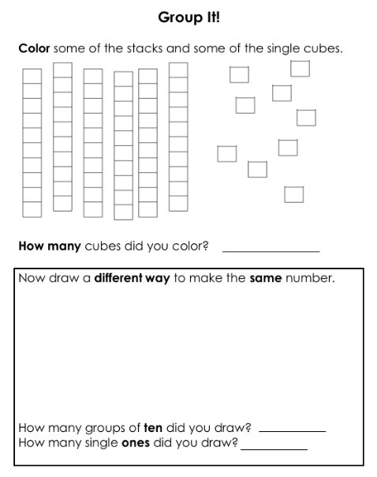  (constructed response)
1.N.2 Understand part-part-whole relationships and 5 and 10 as referents to compose and decompose numbers 0-100. | 1.N.2.1 Understand part-part-whole relationships, including 2 or more parts, doubles, and near doubles.  1.N.2.2 Understand the concept of ten–and-some-more with numbers 11-20.  1.N.2.3 Understand 10 more and 10 less from any given number to 100. | 1.N.2.1 How can 4 + 4 = 8 help you to solve 4 + 5 = 9?  Possible responses: well 5 is only one more than 4. So if 4 and 4 was 8, then 4 and 5 is 9.”  How can 4 + 4 = 8 help you to solve 40 + 40 = 80?  Possible responses: “4 and 4 is a double. It’s 8. And 40 and 40 is a double. It’s 80. See 8… 80.” Or “It looks hard but it’s not! 40 and 40 is a lot like 4 and 4. They are both doubles.”  (constructed response)  1.N.2.1 There are 7 children on the top bunk bed and 6 children on the bottom bunk bed. How many children are there? Explain your thinking.  Possible responses: “7 + 6 = 6 + 1 + 6; 6 and 6 is a double- it’s 12 and one more is 13. 13 children on the bed.” or “7 + 6 = 5 + 2 + 5 + 1 . Because 5 + 5 = 10, then, 10 + 2 = 12 and 12 + 1 is 13. There are 13 children on the bunk bed.” Or “7 + 6 = 7 + 7 – 1. since 7 + 7 is 14, 14-1 is 13. 13 children are on the bed.”  (constructed response)  1.N.2.1 Materials: ten frames, chips, number sentence  Is this true or false: 9 + 3 = 10 + 2 ?  Use ten frames (arithmetic rack) to show your thinking.  Possible responses: “It’s true. See. If I put 9 on one ten frame and 3 on the other I can slide one chip from the 3 over to the 9 to make 10. See, now it’s 10 and 2. All I did was slide one over. So, 9 and 3 is the same amount as 10 and 2.”  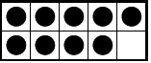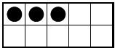  (performance task)  1.N.2.1 Maria spun a spinner 3 times. She landed on 4, 8, and 3. If she added these three numbers together, what would her score be?  Possible responses: “Well, 4 and 3 is 7. I know that 8 and 8 is 16, but this one is 8 and 7. So, it would only be 15. She got 15 points.” Or “I can break apart the 4 into 2 and 2. Then, 8 and 2 is 10. 3 and 2 is 5. So, 10 and 5 is 15. Her score would be 15.”  1.N.2.2 Materials: blank ten frame, chips  If I wanted you to show me 13 chips, what would you do?  Possible responses: “I would fill up the 10 frame first. That’s ten. Then, I would have 3 more because that’s 13.”  (performance task)  1.N.2.2 Materials: ten frame with 7 dots  Show the ten frame. How many dots are there? If we added 5 more dots, would there be enough to make a ten and some leftovers? How many would you need to make a ten? How many leftovers would there be? How many would that be all together? How do you know?  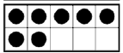  What if we had 17 and we added 5 more? How many would you have all together? How did you figure it out?  Possible responses: “If we had 17, we would need 3 more to make 20. If we took 3 chips off 5, that would leave 2 left. So, we would have 22 altogether.  *adapted from Kathy Richardson, Assessment 7  (performance task)  1.N.2.3 Materials: ten frames  I am going to show you some ten frames. Look carefully. I will then ask you to tell me 10 more than that amount and 10 less than that amount. Ready?  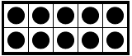  (performance task)  1.N.2.3 Materials: 1-100 numeral cards  I’m going to show you a number. I then want you to tell me what 10 more than that number is. Ready?  30, 26, 78, 19, 8  Now I want you to tell me what 10 less than that number is. Ready?  99, 45, 55, 62, 100  (performance task)
1.N.3 Use efficient strategies to solve a variety of story problems and generate a justification for the reasonableness of the answer. | 1.N.3.1 Use fluent recall of addition facts (sums to 10) and the related subtraction facts to solve problems.  1.N.3.2 Use strategies to solve single and multi-step addition and subtraction story problems to 30.  1.N.3.3. Use strategies to solve single-step addition and subtraction story problems to 100. | 1.N.3 Materials: recording sheet, pencil  Solve: This is today’s Lunch Count. How many children are here today? How many children will have pizza for lunch?  Student Work Example  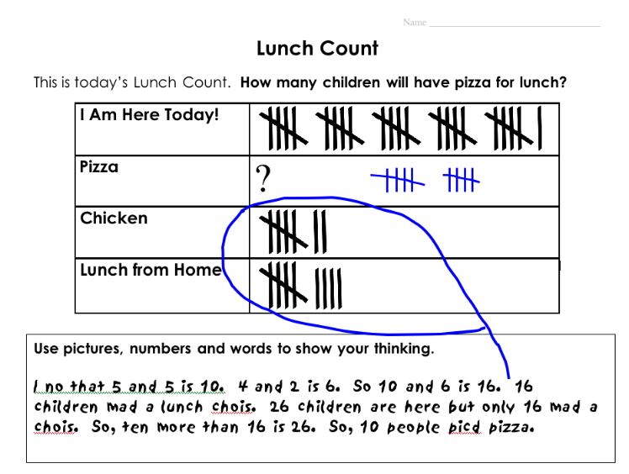  (constructed response)  1.N.3.1 Determine number combination mastery using the Hiding Assessment: Begin with a number that the child may have “mastered”. Have the child count out that many counters into your open hand. Close your hand around the counters and confirm that s/he knows how many are hidden there. Then remove some and show them in the palm of one hand while hiding the rest in your other hand. Ask the child, “How many are hidden?” Repeat with different amounts removed for that particular number. If the child responds quickly and correctly and is not counting, then repeat the entire process with the next higher number. Continue until the child begins to stumble or rely on counting.  *Kathy Richardson, Hiding Assessment #6  (performance task)  1.N.3.1 Materials: paper, pencil  I’m thinking of two different numbers. When you add them together, they make 9.  When I asked people what my secret number might be, they gave me 4 different answers. What do you think their answers were? Were their answers right?  Possible responses: “5 and 4 could be your secret numbers because 5 and 4 is the same as 9.” Or “There are lots of different ways to make nine… 1 and 8, 2 and 7, 3 and 6, 4 and 5. There are more than 4 different answers!”  (constructed response)  1.N.3.2 Solve problems using strategies such as counting-on.  (Join/Start Unknown)  Solve: Charlie had some peanuts. Mrs. Smith gave him 13 more peanuts. Now Charlie has 17 peanuts. How many peanuts did Charlie have to start with?  Possible responses: “(Holding up his fingers) 13 –-- 14- 15- 16- 17. (Showing 4 fingers) 4 peanuts. Charlie had 4 peanuts.”  1.N.3.2 Solve problems using strategies such as using known facts.  (Separate/Change Unknown)  Solve: Daniel had 8 stickers. He gave some to Cedric. Now Daniel has 2 stickers left. How may stickers did Daniel give to Cedric?  Possible responses: “I know that 2 and 6 is the same as 8. So, Daniel gave Cedric 6 stickers.” Or “If he has 2 left. How many until 8. That’s 6. 6 stickers.”  (constructed response)  1.N.3.2 Solve problems using strategies such as using known facts.  (Part-Part-Whole/Part Unknown)  Miguel spun a “Yes/No” spinner 9 times. On 4 spins, it landed on “Yes”. How many times did the spinner land on “No”?  Possible responses: “That’s easy! 5 and 4 is the same as 9. So, it landed on “No” 5 times.”  (constructed response)  1.N.3.2 Solve problems using strategies such as using 5 and 10 as referents.  (Join/Result Unknown)  Solve: 6 ducks were swimming in the pond. 8 more ducks joined them. How many ducks were there then?  Possible responses: “I know that 8 and 2 is 10. If I take 2 off of 6, that leaves 4. 10 and 4 more is 14. There are 14 ducks” Or “I know that 6 and 4 is 10. Then, 10 and the 4 left over from the 8 make 14. That’s 14 ducks in the pond.”  (performance task)  1.N.3.2 Solve problems using strategies such as relating addition and subtraction.  (Separate/Result Unknown)  Solve: There are 9 birds in the tree. 4 of them flew away. How many birds are now in the tree?  Possible responses: “Well, 4 and what make 9. 4 and 5 make nine. So, there are 5 birds still in the tree.” Or “If I had nine… nine is the same as 5 and 4, so there must be 5 birds in the tree. 5 and 4 is the same as 9.”  (performance task)  1.N.3.2 Solve problems using relationships between doubles.  Materials: recording sheet, pencil  Brittany threw 3 beanbags onto the target. Her total score was 25. On what numbers could the beanbags have landed?  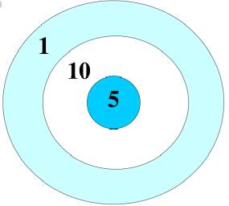  Possible responses: “Well, I know that 10 and 10 is 20. I only need 5 more to get to 25. So, 2 beanbags landed on 10 and one beanbag landed on 5.”  (constructed response)  1.N.3.2 Solve problems using relationships between near-doubles  Solve: Chi rolled a number cube 4 times. He rolled a 3, 9, 4, 8. He thinks his total is 23. Is he right? Why or why not?  Student Work Example  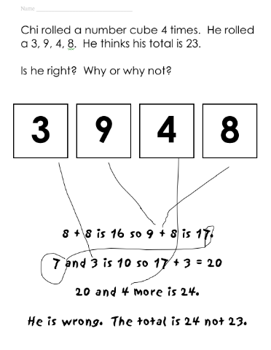  (constructed response)  1.N.3.3. Solve problems using strategies such as applying ten more and ten less.  (Separate/Change Unknown)  Solve: Danielle had some stickers. She gave 20 to Charles. Now she has 32 left. How many stickers did Danielle have at the beginning?  Possible responses: “I think of 20 as 10 and 10. So, if she has 32 and gave 20 to Charles, then that’s 32, 42, 52. She had 52 stickers to start with.”  (constructed response)  1.N.3.3. Solve problems using relationships between 1 or 2 more/less than doubles.  (Compare/Difference Unknown)  Jerome and Anton baked some muffins. Jerome made 40 muffins and Anton made 82 muffins. How many more muffins did Anton bake than Jerome?  Possible responses: “I know that 40 and 40 is 80. So 40 and 41 is 81 and 40 and 42 is 82. So, Anton baked 42 more than Jerome.”  (constructed response)
1.N.4 Understand sharing fairly (equipartitioning) with collections of discrete items and single continuous wholes. | 1.N.4.1 Understand that a region or set must be divided into equal parts of the whole and when reassembled recreates the whole.  1.N.4.2 Understand the concept of “left-over” (remainder).  1.N.4.3 Understand that even numbers are sets that can be shared fairly between two people and odd sets cannot. | 1.N.4 Solve: Mrs. Smith is going to have a party for 5 people. She has 30 mini cookies. She wants to share them fairly between her guests. Will Mrs. Smith have enough cookies to share them fairly? Use words, numbers and pictures to show your thinking.  Student Work Example  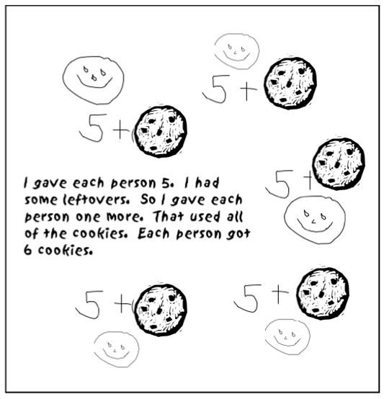  (constructed response)  1.N.4.1 Materials: counters  Count out ten objects.  Share them fairly between the two of us. How many did each of us get? Now push the piles back together. How many counters are there now?  (performance task)  1.N.4.1 Materials: rectangle, pencil  Let’s pretend that this rectangle is a candy bar. How can you share it fairly between the two of us? Use the pencil to show me your idea(s).  Turn the rectangle over. Let’s pretend that we have another candy bar. How can you share it fairly between 3 people?  (performance task)  1.N.4.2 Materials: 11 round cookies, 4 paper plats  I have a pile of cookies here. Count them to see how many are in the pile.  Could you share them fairly between 4 people? Why or why not? Try it. What did you find out?  Possible responses: Hmm… four people… so… two for you, two for me, two for this plate, two this plate. That’s, 2, 4, 6, 8. 8 cookies so far. I have three left over. Hmm… I know! I can cut the cookies in half. You get half of a cookie, I get half of a cookie, the other plates get half of a cookie. I’ve used up all of the cookies! There. We all have the same amount!”  (performance task)  1.N.4.2 Materials: 10 counters  I have a pile of counters here. Count them to see how many are in the pile.  Could you share them fairly between 3 people? Why or why not? Try it. What did you find out?  Possible responses: “I don’t think I can do it fairly. If each person got three, that would be three and three which is six and then three more which is 7, 8, 9. 9 counters used. I have 10. I have some left over” Or “If I gave you 4 and me 4 that’s 8. Then I’d only have 2 left for the other person. That wouldn’t be fair because we wouldn’t all have the same amount.”  How could you share these ten counters without having any leftovers? If you could move the counters, what would you do? Try it and see. What did you find out?  Possible responses: “I could share these 10 counters with 2 people because that would be 5 and 5.” Or “I could give 2 counters to each person… 2, 4, 6, 8, 10. That’s five people.”  (performance task)  1.N.4.3 Materials: Even/Odd Recording Sheet  Which designs have an even number of cubes? How do you know?  Which designs have an odd number of cubes? How do you know?  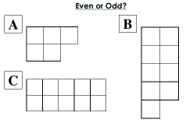  (performance task)  1.N.4.3 Materials: set of 9, 7, and 8 colored tiles  I have three piles of tiles. I need to know which piles are even so that I can share them with you fairly. Which pile(s) should I give you?  Possible responses: “(matches pairs of tiles for each set) You get this pile (pointing to the pile with 8 tiles) because you would get 4 and I would get 4. There aren’t any leftover, so it’s an even amount.” Or “Don’t use these piles (pointing to 7 and 9) because there are leftovers- so they have an odd amount. We wouldn’t get the same amount. This one is the right one to use. Each of us would get 4. So it’s even.”  (performance task)

First Grade Algebra
Mathematical language and symbols that students should use and understand at this grade level:
relationship, balance, +, - =, equal sign, addition sign, subtraction sign, equation, solve, mistake, error, extend, compare, rename, translate
Essential Standards | Clarifying Objectives | Assessment Prototypes
1.A.1  Use models to demonstrate addition properties (commutative, associative, and identity) and the inverse relationship between addition and subtraction. |  | 1.A.1 Materials: number balance, weights, equation  Read this number sentence aloud. 9 + 7 = 7 + 9  If you were to put weights on the number balance, do you think it would balance? Why/Why not? Try it. What happened?  Possible responses: “It would balance because it’s the same thing on both sides. See, both sides have a 9 and both sides have a 7. They’re the same!”  (performance task)  1.A.1 Materials: 10 interlocking cubes: first 6 are blue, last 4 are yellow  How many different number sentences can you write using “+” that represents this tower of cubes?  Possible responses: 6 + 4 = 10; 4 + 6 = 10; 10 = 6 + 4, 10 = 4 + 6  How many different number sentences can you write using “-” that represents this tower of cubes?  Posible responses: 10 – 6 = 4; 10 – 4 = 6; 4 = 10 – 6; 6 = 10 – 4  (constructed response)  1.A.1 Materials: Recording Sheet, pencil  How many true number sentences can you create with these 3 numbers?  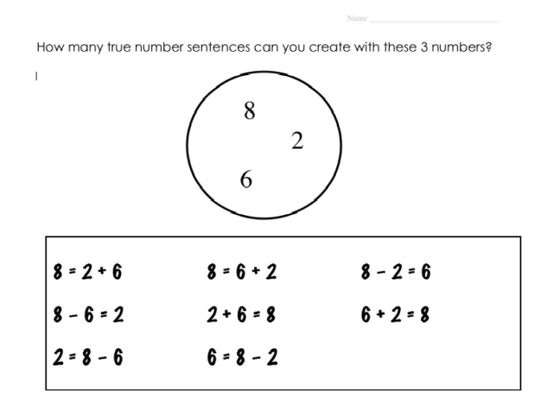  (constructed response)
1.A.2 Apply the concept of equality. | 1.A.2.1 Use the equal sign to show the relationship between one side of the equation and the other.  1.A.2.2 Interpret simple number sentences as models and models as number sentences in order to solve. | 1.A.2 Materials: number balance recording sheet, pencil  How could you hang one or more weights to make this scale balanced? Use words, pictures, or numbers to show your thinking.  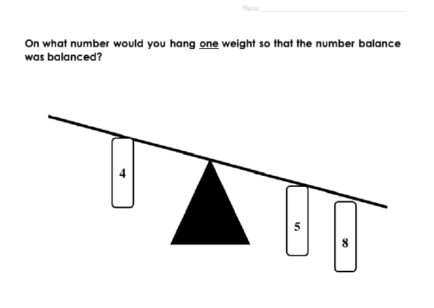  Possible responses: “I would hang it on 9. See. 8 and 5 is like 10 and 3. 13. So, I would need the other side to be 13. It’s on 4 now. If I put it on 10, that would be 14. One less than that is 9. So I would put the weight on 9.” Or “Well, I could hang a weight on 1. That would make the 4 a 5 like the other side. Then, I can put on an 8. That way they are both the same.”  (constructed response)  1.A.2.1 Materials: Number balance recording sheet, pencil  Write a number sentence for this balance.  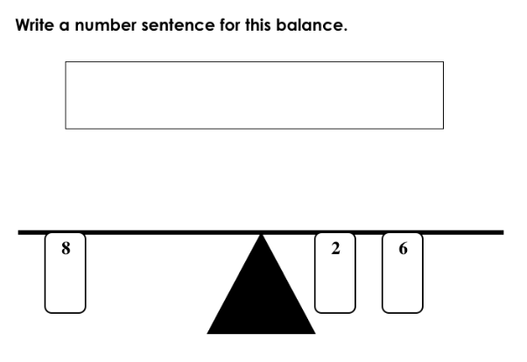  (constructed response)  1.A.2.1 Materials: Recording sheet, pencil  Look at the picture. Draw more apples. Write a number sentence to match your picture.  Look at the picture. Cross off some balloons. Write a number sentence to match your picture.  Student Work Example  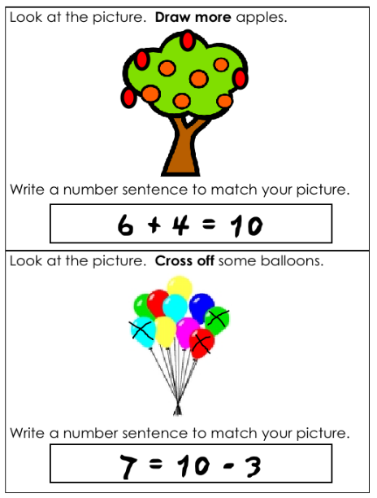  (constructed response)  1.A.2.1 True or False? 44 + 13 = 44 + 12  Why?  Possible responses: “I see that both sides have 44, but one side has 13 and the other side has 12. They are not the same. So, it’s False! They are not equal.”  (Constructed Response or Performance task)  1.A.2.2 Materials: number sentences, 10 blank ten frames, chips  Read the number sentence. Use ten frames to show the number sentence. Explain your thinking to me.  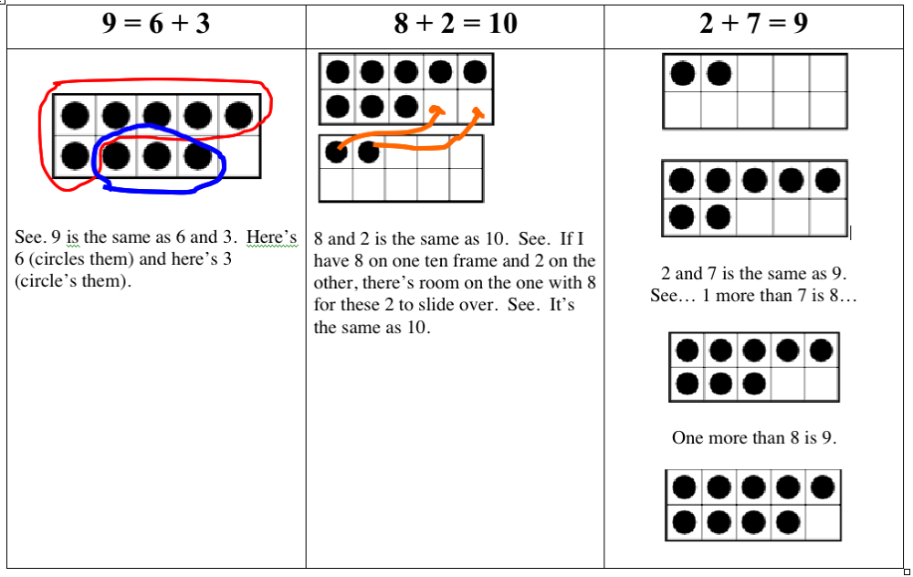  (performance task)  1.A.2.2 Materials: Addition cards, colored links  Pick a card. Make a chain using the links to show the addition sentence on the card.  Repeat.  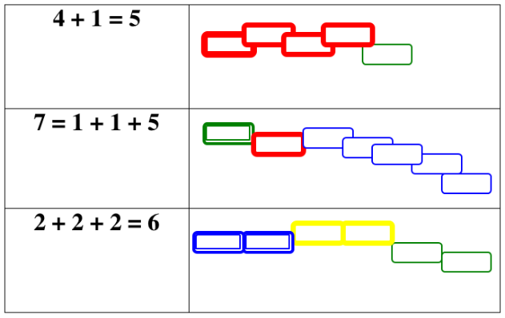  Pick a chain. Write a number sentence that matches the chain.  (performance task)  1.A.2.2 Materials: number sentence: 12 + 10 = 22  What does this number sentence mean? What is it saying?  Possible responses: “Well, you see, 22 is the same as 12 and 10.” or “The amount on this side and the amount on this side are equal- they’re the same amount!” or “If you have 12 counters and you push together 10 more counters, that’s the same as having 22 counters!”  (performance task)  1.A.2.2 Materials: paper, pencil  Solve: Meghan’s teacher told a story-problem to the class. Meghan wrote down the number sentence 16 – 9 =  to match the story. What could the story problem have been?  Possible responses: “There were 16 apples on the tree. 9 fell off the tree. How many apples are still on the tree?” (constructed response)  1.A.2.2 Materials: counters, paper, pencil  Solve: “Maria had some stickers. Brittany gave her 5 more stickers. Now Maria has 13 stickers. How many stickers did Maria have to start with?” Use pictures, numbers or words to show your thinking. (constructed response)  1.A.2.2 Materials: Recording sheet, pencil  What number would you put in the BOX to make the following a true number sentence*?  8 + 4 =  + 5  *Carpenter, 1999  Use words, numbers and pictures to show your thinking.  (constructed response)
1.A.3 Analyze repeating patterns to identify the unit, correct errors in the patterns, and extend the patterns. | 1.A.3.1 Translate patterns into symbolic representations using actions, words and models. | 1.A.3 Solve: There is a mistake in this pattern. Find it and then write a way to fix the mistake.    (constructed response)  1.A.3.1 Materials: AAB letter pattern, tiles  I have a pattern. Read it aloud. A A B A A B A A B  Use these tiles to make the same kind of pattern.  Possible responses: “red-red-green; red-red-green; red-red-green” or “straight, straight, turned; straight, straight, turned; straight, straight, turned”  Now use your body to make the same kind of pattern.  Possible responses: “jump, jump, clap; jump, jump, clap; jump, jump, clap” or “stomp, stomp, snap; stomp, stomp, snap; stomp, stomp, snap”  (performance task)

First Grade Geometry
Mathematical language and symbols that students should use and understand at this grade level:
parallelogram, rhombus, trapezoid, hexagon, prism, pyramid, round, flat, side, edge, vertex, angle, corner, attribute, property, above, below, between, farthest, closest, left, right, behind, through, in front of, design, figure, shape, solid

Essential Standards | Clarifying Objectives | Assessment Prototypes
1.G.1  Classify two-dimensional figures (polygons) as parallelogram, rhombus, trapezoid and hexagon and three-dimensional figures (polyhedra) as prism and pyramid according to geometric attributes. | 1.G.1.1 Describe the attributes of the figures, such as: number of faces or edges, equal sizes of sides, numbers of angles.  1.G.1.2 Use the attributes of figures to recognize different variations of figures. | 1.G.1 Materials: duplicate set of 2D and 3D figures with one set in a bag  I have some shapes out on the table. I am going to put in a mystery shape in the bag. You will reach in the bag, and feel it carefully. Use words to describe what you feel. Then, decide which shape on the table is in the bag.  Possible responses: “It feels round like a ball. It doesn’t have any vertices. It’s a sphere!” or “It only has 3 sides. It’s a triangle!”  (performance task)  1.G.1.1 Materials: various 2-D figures  I have a collection of shapes. Sort them according to your own rule. What is your rule? Sort them a different way. What is your rule? Sort them a different way. What is your rule?  Possible responses: “I put all of the shapes with 3 sides in one pile, all of the shapes with 4 sides in one pile, and all of the shapes with 5 sides in this other pile.” Or “I put all of the shapes with straight sides in one pile and all of those that don’t in this pile.” Or “ I counted the angles of each shape and sorted them that way.”  (performance task)  1.G.1.1 Materials: various 3-D figures  I have a collection of shapes. Sort them according to your own rule. What is your rule? Sort them a different way. What is your rule? Sort them a different way. What is your rule?  Possible responses: “I put all of the shapes that have a square as a face in one pile and all of those that do not in another pile.” Or “I counted the number of vertices and put them in piles by that number.”  (performance task)  1.G.1.1 Materials: What Am I? clues, 2-D and 3-D figures  Listen to the clue. Then, choose the shape that matches the clue.  I have 4 sides.  All of my sides are the same size.  What am I?  I have only squares as my faces.  I have 6 faces.  What am I?  I have 2 square faces.  I have 4 rectangle faces.  What am I?  I have three sides.  I have three angles.  What am I?  (performance task)  1.G.1.2 Materials: Shape recording sheet  Find all of the parallelograms. How do you know that they are parallelograms?  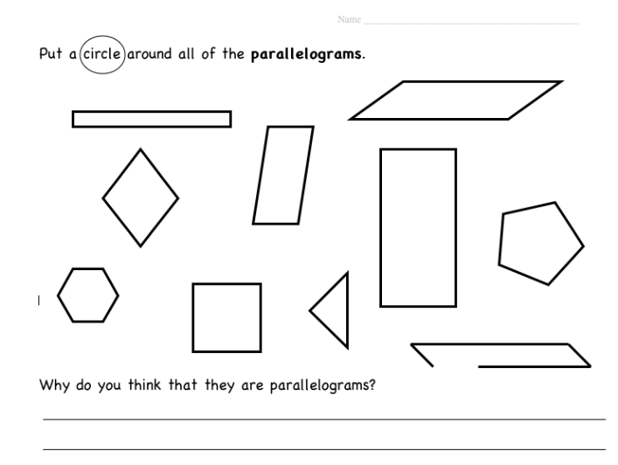  (constructed response)  1.G.1.2 Materials: geoboards, rubber bands  Use rubber bands to make a triangle. How many different triangles can you make?  Student Work Example  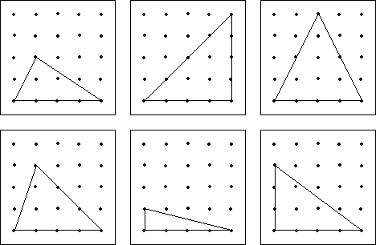  How do you know that they are triangles?  Possible responses: “They are all triangles because they have three sides and three angles.”  (performance task)
1.G.2 Compare geometric figures in terms of their perspectives and orientations. | 1.G.2.1 Summarize relationships of objects using proximity, position, perspective, and orientation, and navigation.  1.G.2.2 Compare different perspectives and orientations by composing and decomposing geometric figures. | 1.G.2 Materials: triangle, square, trapezoid, hexagon, circle; overhead/smartboard/document camera  I’m going to show you 5 shapes. You will need to look carefully at the shapes. Then, I’m going to ask you questions about the shapes and where you see them. Ready?  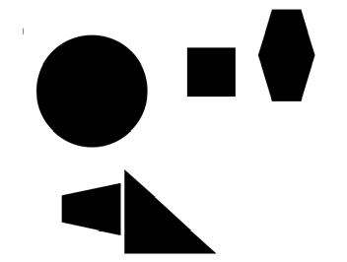  Is the triangle above or below the square?  What shape is between the hexagon and the circle?  What shape is farthest from the trapezoid?  What shape is closet to the triangle?  (performance task)  1.G.2.1 Materials: treasure map  Look at this map. There is a treasure buried somewhere on the map. Can you find it? Where is it? If I was standing here (pointing to the smiley face), and I couldn’t see the map, how would you tell me how to get to the treasure?  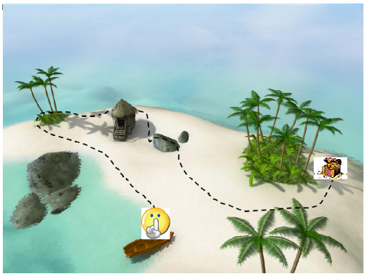  Possible responses: “Go left and up to the three palm trees. Go behind the palm trees and the hut. Hop over the rock and go through the trees. The chest is behind all of the palm trees.”  (performance task)  1.G.2.2 Materials: Top-Down View display, 3-D figures  Imagine standing tall above a building and looking down. You only see the top of the building. Use these blocks to create a building, so that when you stand above it and look down you see this picture.  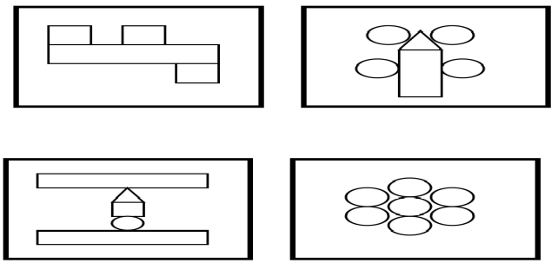  (performance task)  1.G.2.2 Materials: 1 set of tangrams, tangram puzzle  Fit all of your 7 tangrams in this puzzle to make a turtle.  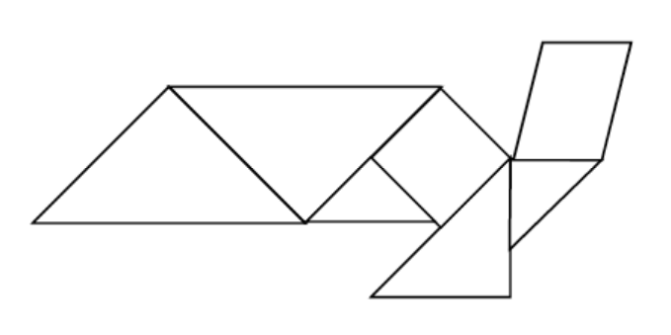  (performance task)  1.G.2.2 Materials: set of shapes (same color), flash designs  I’m going to show you a picture of a design. I’ll show it quickly. Look carefully at it. Then, use your blocks to make the same design. Ready? Ok, now you build it. Now, let’s look at yours and mine. Are they the same? How did you know where to put the shapes? OK, now I’m going to show you another design. Ready? Ok, now you build it. Now, let’s look at yours and mine. Are they the same? How did you know how to make the design?  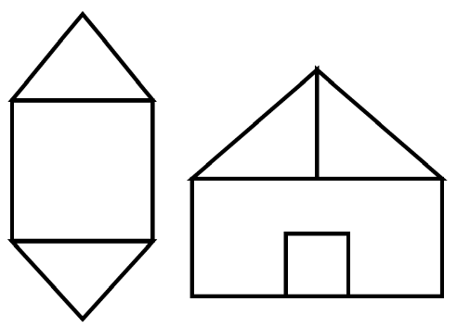  (performance task)  1.G.2.2 Materials: pattern blocks, paper, pencil  If 1 triangle is worth 2 points, how many points is 1 hexagon worth?  What if the triangle is worth 5 points? How many points would 1 hexagon be? How many points would 2 hexagons be? Use words, numbers and pictures to show your thinking.  (constructed response)

First Grade Measurement
Mathematical language and symbols that students should use and understand at this grade level:
measure, weigh, balance, estimate, more than, less than, exactly, calendar, days of the week (read and write), months of the year (read and write), day, week, month, year
Essential Standards | Clarifying Objectives | Assessment Prototypes
1.M.1 Use nonstandard units to estimate and measure length or weight* of objects.  *More properly mass, but most commonly operational as weight at this grade band. | 1.M.1.1 Compare objects in terms of appropriate non-standard units of measurement.  1.M.1.2 Use comparative vocabulary to describe the relationship among three to five objects with respect to length (longer, shorter), weight (heavier, lighter) or duration. | 1.M.1 Materials: color tiles, strip of tape 15 inches long  Place one tile on the end of the strip of tape. I wonder how long this piece of tape is. If I know that one tile measures this much, do you think that it will take more than 10 tiles, less than 10 tiles, or exactly 10 tiles to measure it? Why?  Possible Responses: “I think that it will take more than 10. If one is this much, then five must be somewhere around here, and then there’s still a lot left over.” Or “1 tile doesn’t cover too much. I think more than 10.”  Measure the tape using the tiles. As the child is measuring ask, do you want to keep your same estimate or change your estimate? Why? Why not?  Possible Responses: “I think I’ll keep my same idea. See, I’m already at 7 and still have lots more tape left.”  What did you discover?  Possible Responses: “I found out that it did take more than 10! I was right! It took 15 tiles to measure it.” or “I found out that the piece of tape is 15 tiles long. I was right!”  (performance task)  1.M.1 Materials: 7 toothpicks, 7 straws, tape  I have 7 toothpicks. If you were to line them up, how far would they reach? Put this piece of tape where to show where you would start and use this other piece of tape to show where you think it would end. Now, let’s try it. As you put each toothpick down, tell me if you think your estimate is too short, too long, or okay. What did you find out?  Now, I have 7 straws. If you lined them up, how far would they stretch? Do you think that it would be longer or shorter than the toothpicks? Why or why not?  Notice if the student is able to measure with the nonstandard units without any gaps or overlaps. Is the student able to make a new estimate of the same quantity using a different unit? (performance task)  1.M.1.1 Materials: Recording sheet, pencil, popcorn kernels, pennies, pencils  I want to know which path is the longest. I have popcorn kernels, pennies, and pencils to measure with. Choose something to best measure the paths. Measure. Then, use words, pictures or numbers to show what you discovered.  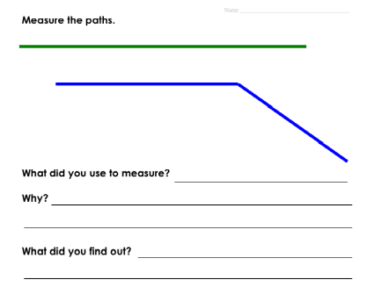  (constructed response)  1.M.1.2 Materials: bucket/pan balance, cubes, pennies, pinecone, apple, small rock  Here are three objects: a pinecone, an apple, and a small rock. Without touching them, which one do you think is the heaviest? Lightest? Why do you think so?  Now, touch them and hold them in your hands. Which do you think is the heaviest? Lightest? Did you change anything from your first guess?  Now, use the balance to compare them. Which is the heaviest? The lightest? In between? How do you know?  (performance task)  1.M.1.2 Materials: 3 event cards (getting to school, brushing teeth, sleeping at night)  I have 3 cards here that show things that you may do. Look at them and tell me what you see. If the student is not able to interpret the card, tell them what it is. Put these cards in order by how long it takes to complete the event. Start here for the one that takes the least amount of time.  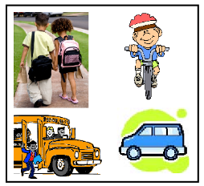  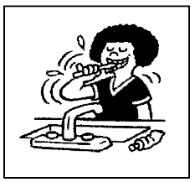  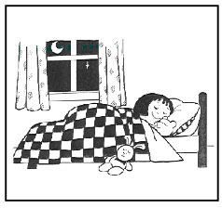  (performance task)
1.M.2 Use the names of the days of the weeks and the months of the year to describe special activities and events. | 1.M.2.1 Remember in order the names of the days of the week and months of the year.  1.M.2.2 Recognize the difference in the amount of time between a day, week and month. | 1.M.3  Materials: calendar example, pencil  This class calendar is filled with special days and events.  On which days does the class have a special event? On what day of the week is the class going to the zoo? On what day of the week does the class have PE? On what day of the week does the class go on a spider hunt? This calendar is for the month of October. What is the month that comes before October? After October?  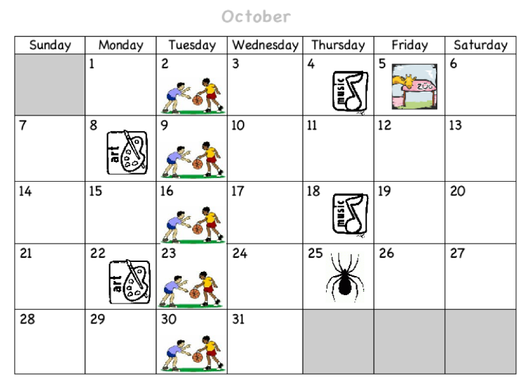  (constructed response)  1.M.3.1 Solve: If it is January 1st, which month will come first? August or March? How do you know? (constructed response)  1.M.3.2 Solve:  Which is longer? A week or a month? How do you know?  Possible responses: “A month is longer because it has lots of days and a week only has 7 days.” Or “A month is longer because it’s made up of weeks. Months don’t make weeks.”  Which is shorter? A day or a month? How do you know?  Possible responses: “A day is shorter. A month is a long time. See- pointing to the calendar. All of these squares are days. But a month needs lots of squares.” Or “A day is shorter than a month. A month is made up of lots of days. A day is not made up of lots of months. That would be silly!”  (constructed response)

First Grade Statistics and Probability
Mathematical language and symbols that students should use and understand at this grade level:
rule, attribute, sort, all, none, collect, organize, display, show, question, answer, picture graph, line plot, tally (ies), label
Essential Standards | Clarifying Objectives | Assessment Prototypes
1.S.1 Infer the rule for classifying objects on the basis of two attributes. | 1.S.1.1 Explain how a collection of objects with various attributes can be classified or sorted in different ways. | 1.S.1 Materials: set of pre-sorted red and blue letters  I have sorted a set of letters, but I have some left over. Do any of the left over letters fit anywhere? Why do you think so?  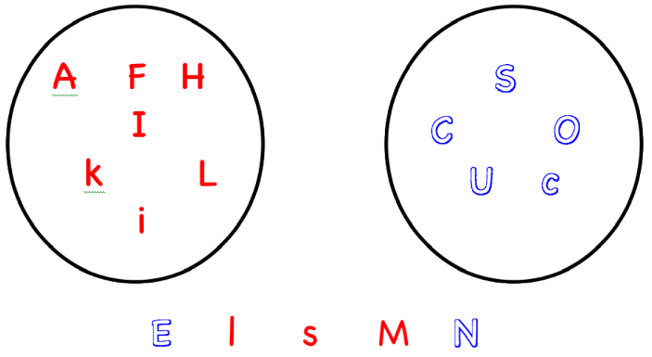  (*Note: Because of black/white duplicating, this example continues to talk about color, but” filled in” letters and “non-filled in bubble-like” letters help to distinguish the differences for this example.)  Possible responses: The E doesn’t fit because it’s blue. All of the straight line letters are red” or “The l fits because it’s straight and red” or “The s does not fit because it’s red and all of the curvy letters are blue” or “The M fits because it’s both red and straight lines” or “The N does not fit anywhere. It’s blue, but it’s not curvy.”  (performance task)  1.S.1 Materials: set of attribute blocks, sorting mat  I have some attribute blocks. Hold up a big thick triangle with squiggles. What can you tell me about this block? Hold up a small thin circle with stripes. What can you tell me about this block?  Now, I want you to sort the blocks using two attributes. If some of the blocks don’t fit your rule, then you can put them off to your side.  Student Work Sample  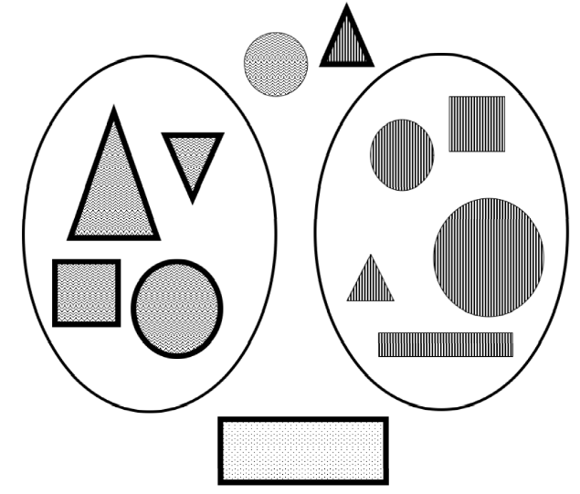  Possible response: “I put all of the thick shapes with squiggles in one circle and all of the thin shapes with stripes in the other circle. I put the ones that didn’t fit outside of the circles.  (performance task)  1.S.1.1 Materials: set of sorting cards  I have a set of cards. Look at them carefully. What are possible ways that they can be sorted?  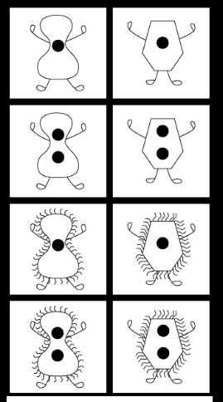  *John Van de Walle, 2006  http://wps.ablongman.com/ab_vandewalle_math_5/0,7959,796754-,00.html  Possible responses: one dot/two dots; curly people/not curly people; body with curvy lines/body with straight lines; red/blue  (performance task)
1.S.2 Use appropriate methods to collect, display, analyze and interpret statistical data in response to specific questions. | 1.S.2.1 Represent data collected using picture graphs, line plots, lists and tallies to capture and represent categorical and numerical data. | 1.S.2 Materials: What is your favorite __________? recording sheet, pencil, crayons  What are five different ways this question could be finished? Choose your favorite. What are three different possible answers to your question?  Ask 10 of your classmates your question and keep track of their answers. Show your results using either a line plot or a picture graph.  What does your data tell you about your question?  (constructed response)  1.S.2.1 Materials: unfinished graph, pencil, recording sheet  A group of first graders made this graph, but it is missing some information. What information is missing that would help you understand their graph?  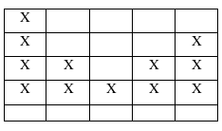  Possible responses: “I don’t know what the question is.” Or “I see that people’s answers are here, but I don’t know what they picked.” Or “It needs labels on the bottom to tell me what my choices are and it needs a title/question so I know what I’m answering.”  Even though information is missing, what do you know about their class graph?  Possible responses: “I see that one choice has 4- the most- but I don’t know what that stands for.”or “I see that 12 people answered the question.” Or “I see that 2 of the columns/categories tied with two.”  (performance task)  1.S.2.1 Materials: two different data displays  Choose the class graph that best answers the question, “How many vowels are in your name?” Use words, numbers and pictures to explain your choice.  A 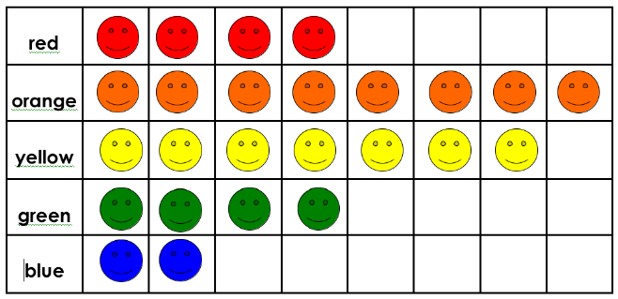  B 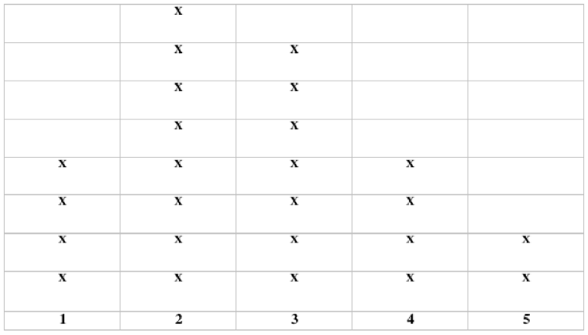  Possible responses: “I chose B. I didn’t choose A because it gives information about color and that’s not what the question was about.” Or “I chose B because it has numbers as the choice for the vowels. Vowels are not colors.”  (constructed response)

