Important Note: The NC State Board of Education mandated that the adopted 2008 K-5 mathematics curriculum be revised using the same Essential Standards lens as A Framework For Change required of all standards. While this comes very quickly on the heels the recently adopted standards, this revision is important to ensure alignment and to build a sound, consistent mathematics program from Kindergarten through 12th grade. The big ideas in the 2008 standards are still present but may be reworded and, in some cases, moved to a different strand or grade level in these drafts. While writing these standards, the Revised Bloom's Taxonomy is being used to ensure uniformity and consistency in language and ensure the rigor of the standards.

Essential Standards • Math Grade 2

Number and Operations
2.N.1 Represent whole numbers from 0 through 1,000 in terms of the base ten numeration system.
2.N.2 Use multiple strategies fluently to solve story problems involving addition and subtraction.
2.N.3 Understand the concept of division as fair shares (equipartitioning).

Algebra
2.A.1 Classify numbers into the categories of odd and even.
2.A.2 Represent situations found in story problems as number sentences with unknowns.
2.A.3 Understand patterns as repeating or growing.

Geometry
2.G.1 Classify the faces of polyhedra (cube, cylinder, triangular prism, rectangular prism, triangular pyramid, and rectangular/square pyramid) as polygons.
2.G.2 Compare polygons to determine whether they are or are not congruent.

Measurement
2.M.1 Understand the use of non-standard units in measurement of length, weight, capacity and area.
2.M.2 Use analog and digital clocks to tell time to the hour and half hour.
2.M.3 Use strategies to count money collections up to one dollar ($1).

Statistics and Probability
2.S.1 Understand data from statistical investigations in order to develop and evaluate inferences and predictions.

2nd Grade Number and Operation
Mathematical language and symbols that students use and should understand at this grade level:
Digit, place value, ones place, tens place, hundreds place, base ten blocks, standard notation, expanded notation, word form, numeral, before, after, more, set, greatest, least, less, greater than, less than, estimate, region, set, part, whole, fraction, halves, thirds, fourths, fair share, equal shares, equivalent, left over, remainder, sum, difference, single digit, multi-digit,
Essential Standards | Clarifying Objectives | Assessment Prototypes
2.N.1 Represent whole numbers from 0 through 1,000 in terms of the base ten numeration system. | 2.N.1.1 Illustrate whole numbers to 1,000 in groups of ones, tens, hundreds, and thousands by composing and decomposing flexible groups.  2.N.1.2 Interpret the value of a digit (1-9, and 0) in a multi-digit numeral by its position within the number with models, words and numerals.  2.N.1.3 Use benchmark numbers (25, 50, 75, 100, 200, etc.) to determine a reasonable estimate.  2.N.1.4 Understand counting by 10’s and 100’s on and off the decade.  2.N.1.5 Compare whole numbers less than 1,000 with symbols (<, >) and words. | 2.N.1 Use base ten blocks and build the numbers, 9? 39? 539? How is 539 different from 19?  Solutions:  9: nine ones cubes  39: 3 tens rods and nine cubes OR 2 tens/19 cubes OR 1 ten/29 cubes OR 39 cubes  539: 5 hundreds, 3 tens, and 9 ones; OR 4 hundreds, 13 tens, 9 ones; OR 5 hundreds 2 tens and 19 one; etc.  (Performance task OR constructed response)  2.N.1.1 What number does this base ten model show? Write your answer in word form, standard form, and expanded form. How else can this number be represented with base ten blocks? Find two more ways and show your thinking with pictures, numbers and words.  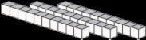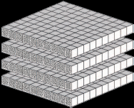  Possible solutions: this number would be written as:  Word form: four hundred forty-five  Standard form: 445  Expanded notation: (various answers possible) 400 + 30 + 15= 445 OR 400 + 40 + 5 = 445 OR 445 = 15 + 30 + 400  For other ways to show the same value, students must show ability to compose or decompose with the models, pictures or in number form. One example would be: 300 + 130 + 15.  (constructed response)  2.N.1.2 Materials: Base ten blocks, white board & marker (or paper and pencil)  Please count out 32 for me using these materials. Student should make a collection of three tens rods and two unit blocks (or 32 unit blocks- follow up with the question, “Is there a way we can group these blocks by tens?”). Please write the number that shows this collection on your white board. Point to the “3.”Can you point to where this number is in your model? Student should be able to point to the three tens (either the rods, or the groups of tens). Now count out 208 with your blocks. Students should have two hundreds flats, no tens rods, and eight unit blocks. Point to the 2. Point to your model and show me what this digit means in your number. Student should point to the two flats (or other representation of 200). Point to the zero. Can you show or tell me what this digit means in your number? Student should say that there are no tens, or point to a blank spot to illustrate “no tens.” (performance task)  2.N.1.2 In the number 895, what does the “8” represent? What are three forms for representing the value of this number?  Possible Solutions: The 8 represents 800.  8 hundreds (800)  7 hundreds and 10 tens (700 + 100)  6 hundreds and 20 tens (600 + 200), etc.  (constructed response)  2.N.1.3 Given a bag of marshmallows, estimate the number in the bag. Would 1,000 be a reasonable estimate? Why or why not?  Solution: There are usually around 40 large marshmallows in a bag. Estimates should be between 25 and 75. One thousand would not be a reasonable estimate. Students could say that they can only hold 5 in their hand, and there’s about 10 handfuls in the bag, OR They can see that 10 marshmallows are visible in the corner of the bag, so 1,000 wouldn’t fit. (constructed response)  2.N.1.3 Show where the numbers below would be on the number line. Tell what benchmark number is closest to each number given.  99 425 213 250 385  0 100 200 300 400 500  Solution: 99 closest to →10  425 closest to → 400  213 closet to → 200  250 is in the middle so the rule we follow is to round up→300  385 closet to → 400  2.N.1.4 How does adding 10 change the number 134?  Solution: Adding ten to 134 makes the digit in the tens place go up by one. So the answer would be 144. (constructed response)  2.N.1.4 Start at 47 and count by tens for me.  (Solution: 57, 67, 77, 87 97, 107, 117 … allow the student to go up over the century mark to show understanding of that transition.)  Now start at 652 and count down by one hundreds.  (solution: 552, 452, 352, 252,152, 52.)  How did you know what the next number was going to be?  Possible solution: “I know that when I am counting by 100’s, the digit in the hundreds place is the only one to change, so if I am counting down from 6 hundred something, then it will be five hundred and the same part that is in the tens and ones places. It is the same when you count by tens. Only the number in the tens place changes, until you get up where you have hundreds.” (performance Task OR constructed response)  2.N.1.5 Are 25 and 35 together more or less than 5 tens? Explain how you know. Solution: They are bigger than ten fives together because 2 tens (from the 25) and 3 tens (from the 35) would make 5 tens, and then there are some ones to add together which would make it more than five tens by themselves. (constructed response)  2.N.1.5 Look at these five numbers:  34 28 10 42 21  What are two numbers we could combine that would be more than five tens? Is there another pair?  Possible Solutions: Student should have two of the following pairs (they do not have to give an answer to actually adding them together- this is an estimation question where front end estimation can be used.): 34 & 28; 34 & 42; 34 & 21; 28 & 42; 10 & 42; and 42& 21. (constructed response)  2.N.1.5 Tell which of the following expressions is true:  - 789 > 798  - 50 + 100 = 150  - 460 < 640  - 900 = 40 + 50  How can you change the false statements to make them true?  Solution: correct expressions: b & c. Solutions will vary to make a and d correct. (constructed response)
2.N.2 Use multiple strategies fluently to solve story problems involving addition and subtraction. | 2.N.2.1 Remember addition and related subtraction facts (sums to 20) to develop fluency.  2.N.2.2 Use properties of addition to solve story problems.  2.N.2.3 Use benchmark numbers to facilitate mental math strategies, estimation, and judging reasonableness of answers.  2.N.2.4 Apply strategies to compose and decompose when adding and subtracting whole numbers less than 300. | 2.N.2 Randy, Carl, and Jim found a dollar bill last week. They decided to turn it in to the office to see if anyone would claim it. The secretary told them that if it hadn’t been claimed in a week, then they could have it. They got the dollar bill today, so they have to decide who should get how much. Randy saw the dollar bill first, so he thinks he should get the most. Carl ran to pick it up, and Jim had the idea to turn it in at the office. Show three different ways that the boys could split the dollar and explain why each is reasonable. Show your work in pictures, numbers and words.  Possible solutions: The money can be divided into various collections to show each boys’ share, however, each arrangement must add up to $1. For example:  Sample Collection #1:  Randy should get the most because he saw it first, so he gets 50¢.  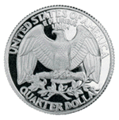  Carl picked the dollar up, so he gets the next largest amount, 30¢  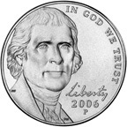  And, Jim gets the least amount because he never touched the dollar. He gets 20¢  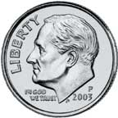  Sample Collection #2  They should each get the same amount, which is 33 ¢ each. The penny that they have left over, they put in the Pennies for Patients jar in the school office.  Each boys’ collection looked like this:  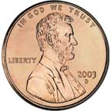  (performance task or constructed response  2.N.2.1 Materials: ten frames cards to flash sums to 10, scoring sheet (optional)  Beginning of the year: When I flash a card up you tell me what fact it shows as quickly as you can.  Note number correct (see score sheet in the teacher support materials). At other times of the year, students are quizzed again. Document the number the child is able to do correctly, noting progress over time, until the child is able to do all correctly.  Solutions: If a card has 3 dots, the tens fact is 3 + 7 = 10 OR 7 + 3 = 10. (performance task)  2.N.2.2 Vivien and Janet both had planted flower bulbs in their yards. Vivien planted 247 tulips, and 145 daffodils. Janet planted 145 tulips and 247 daffodils. Did one girl plant more than the other? How do you know?  Solution: Children should NOT compute this problem- they need to see that 247 + 145 is the same as 145 + 247 (commutative property of addition). (performance task or constructed response)  2.N.2.3 Carol bought 40 water bottles to give out at field day. She then bought 60 more. How many bottles did she buy?  Solution: Students should be able to apply their tens facts to know that 4+6=10, so 40+ 60=100. (performance task OR constructed response)  2.N.2.3 Susan checked in 300 bicyclers for Saturday’s race. Joy checked in 600. They had 1,000 bags to give to the people in the race. About how many bags did they give out? Did they have enough bags?  Solution: Students should NOT compute this problem. They should apply the 3 + 6 = 9 fact to know that 300 + 600 is 900. So they had about 100 more bags to give out. (performance task or constructed response)  2.N.2.4 Build 247 with base ten blocks. Build 15 with base ten blocks. When 247 and 15 are added together, what regrouping would need to be made to find the final answer?  Solution: The five ones and 7 ones would need to be combined (regrouped) to make 1 ten and 2 ones. So there are 2 hundreds, 6 tens and 2 ones. (constructed response or constructed response)  2.N.2.4 Kyle collects baseball cards and keeps them in a notebook that holds 300 cards. He only has 85 spaces left. How many cards does he have in his notebook? Use an open number line to find the answer.  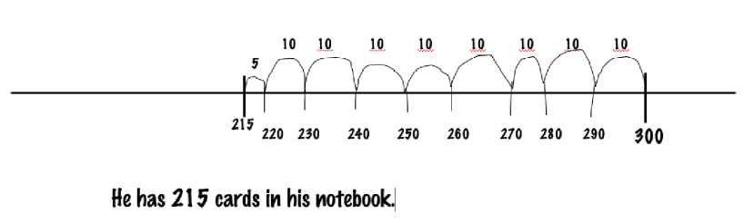  2.N.2.4 Kyle’s grandmother sent him a bag of new baseball cards. There were 5 packs with three cards in each pack. Will these cards fill up his book? If not, how many spaces will be left? How do you know? (constructed response)
2.N.3 Understand the concept of division as fair shares (equipartitioning). | 2.N.3.1 Illustrate division by making equal sized groups using models.  2.N.3.2 Interpret verbally the share as “1/nth of the whole” and the whole as “n times as much" as the share.  2.N.3.3 Understand the relationship between the size of a fair share (of a set or of a single continuous whole) and the number of people sharing (compensatory principle). | 2.N.3 Show two ways to solve the following problem: Janet had 24 sea shells. She puts five shells into each bag. How many bags will she fill? Will there be any shells left over?  Solution: Students should either do this with manipulatives or with a drawing on paper. Janet should end up with four bags with five shells each, and four shells left over. (constructed response)  2.N.3.1 Three children want to share two candy bars so that each child gets the same amount. How much would each child get? (Issues: in sharing, each child will get less than a whole; and each child will receive more than a unit fraction)  Solution: Students should have a drawing of two candy bars, each divided into three equally sized pieces. It should indicate that each child gets two of the pieces. They do not have to write the fraction 2/3. They should be able to say that the pieces are 1/3 (naming the unit fraction)and that each child gets two of the thirds.  (performance task or constructed response)  2.N.3.1 Four children are sharing nine blueberry pancakes so that each child gets the same amount. How much does each child get? (Issue: sharing where everyone gets a whole, and a fractional amount.)  Solution: Each child gets two wholes and” one fourth” of the last pancake (Students should show this answer in a drawing, and be able to tell that the last piece is one fourth, but they do not have to write “1/4”) (performance task or constructed response)  2.N.3.2 Jack invited seven friends to his party. His mom had bought a round cake to serve all eight children. If they eat all of the cake, and each child gets an equal sized piece, how much does one child get?  Solution: Students should be able to verbally say that one child gets “one-eighth” of the cake and that there are “eight slices make whole cake.” (performance task or constructed response )  2.N.3.3 Dennis and Jacob are going to share six cupcakes evenly. Tell what happens when their friend Jonathan shows up. How many does each boy get now? How is that different from what Dennis and Jacob would get by themselves?  Solution: At first, Dennis and Jacob have six cupcakes to share for the two of them, so they each would get three. When Jonathan comes, they have six cupcakes between three people, so they each get two cupcakes. The more people, the smaller their share.  (performance task or constructed response)  2.N.3.3 Addison and Ethan had a pie in their picnic basket. If they decide to share it fairly, how much would each of them get?  Solution: student should be able to say,“1/2.”  Right after they divided up the pie, but before they served it, their friends Mirabella and Brandy showed up. They want to share the pie with them, so now how much pie do they get? Is it more or less than they would have gotten if it was just two people sharing.  Solution: they would each get “1/4.” They would be getting less pie with four sharing than they would with two sharing.  (performance task or constructed response)

2nd Grade Algebra
Mathematical language and symbols that students use and should understand at this grade level:
Pattern unit, repeating patterns, growing patterns, ordinal numbers, number sentence, equals, equation, number model, even, odd, dozen, pair, unknowns, variables,
Essential Standards | Clarifying Objectives | Assessment Prototypes
2.A.1 Classify numbers into the categories of odd and even. |  | 2.A.1 Two students chose a number card from the deck, which are shown below:  Susie Kitty  Which girl had a card with an even number of dots? How do you know?  Solution: Kitty has the card with the even numbers of dots. I know this because I can partner pair all of the dots with no leftovers. (constructed response)  2.A.1 Shakila rolled a die 4 times. Each time she rolled she ended up with an odd number of dots. What numbers do you think she rolled? Why?  Possible solutions: Any combination of 1,3,and 5. Justification includes the idea that odd numbers are those that have a “left-over”, or cannot be made of two equal parts, or that every dot does not have a pair/partner. (constructed response)  2.A.1 I’m thinking of a number that is even and is in between 15 and 20. What is my number? Why do you think so?  Possible solutions: 16 or 18. Justification provides understanding that even numbers consist of amounts that can be made of two equal parts with no leftovers. (constructed response)
2.A.2 Represent situations found in story problems as number sentences with unknowns. |  | 2.A.2 Write a number sentence to show the following problem: Jim had six children in his family. Two of them were girls. How many boys were there in his family?  Possible Solutions: 6 – 2 = ; + 2 = 6; 2 + =6  (constructed response)
2.A.3 Understand patterns as repeating or growing. | 2.A.3.1 Apply patterns to properties of numbers and operations. | 2.A.3 Use your pattern blocks to make a growing pattern. Draw it on your paper. Possible Solution:  (constructed response)  2.A.3 Jason made a repeating pattern with soda cans and cardboard boxes. When he came back from recess several pieces were gone. Help him figure out what cans or boxes need to go back in the pattern to make it right. Draw an arrow from the shape to where it goes in the pattern.  Solution:  (Multiple choice)  2.A.3 Mary, Robin and Emily made an ABBCC pattern by slapping their legs for A, Clapping their hands for the B, and snapping their fingers for C. With three friends together in a group, do the pattern, and keep it going at least three times. Make a growing pattern with the same A, B, and C.  Solution: Students either all at once, or each person taking a part(slap, clap or snap) and perform the pattern as follows:  Slap, clap, clap, snap, snap, slap, clap, clap, snap, snap, slap, clap, clap, snap, snap. Students will create various growing patterns with the clap, snap and slap movements (e.g. ABC, AABBCC, AAABBBCCC, or ABC, ABBC, ABBBC, ABBBBC, ETC.)  (performance task)  2.A.3 Hunter found some magic seeds. When he planted them, the plant that grew looked like this:  Day 1 Day 2 Day 3  If it continues to grow the same amount each day, how many squares will there be on day 4? How many triangles on day 4? How do you know? Draw what the magic plants will look like on days 4 though 6. (constructed response)  2.A.3.1 When Mary started at the number 3 and made jumps of 5 over and over again she said that she saw patterns. What do you think she saw?  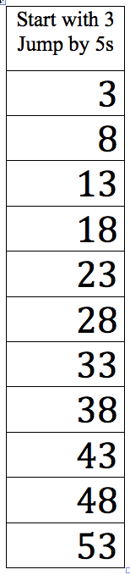  Possible responses: There is an alternating pattern, there is an odd/even pattern, there is a pattern in the tens place (00112233etc) and in the ones place (383838383838etc.), and there is a pattern when you add the digits in each row (3, 8, 4, 9, 5, 10, 6, 11, 7, 12, 8, etc.) (constructed response)  2.A.3.1 How many different ways you can add to numbers to make 9? Use pictures, numbers and words to explain your thinking.  Note: Notice if students have an organization about approaching this problem (such as 0 + 9, 1 + 8, 2 + 7, etc) or is they are haphazard in their thinking and notation.  Solution: There are 10 combinations, if the commutative pairs are counted. (constructed response)

2nd Grade Geometry
Mathematical language and symbols that students use and should understand at this grade level:
Angles, sides, faces, surfaces, edges, vertex/vertices, polygon, polyhedron (plural- polyhedra), net, figure, congruent, turn, flip, 2-dimensional, 3-dimensional, rectangular prism, triangular prism, rectangular or square pyramid, triangular pyramid, cube, cylinder
Essential Standards | Clarifying Objectives | Assessment Prototypes
2.G.1 Classify the faces of polyhedra (cube , cylinder, triangular prism, rectangular prism, triangular pyramid, and rectangular/square pyramid) as polygons. | 2.G.1.1 Classify angles as greater than, equal to, or less than a right angle. | 2.G.1 Look at this figure. If you cut it out, and fold it on the lines, what 3-D figure will it make?  Solution: This shape has four triangles and one square, so it will be a square pyramid when it is put together. (constructed response)  2.G.1 Which of the polygons below would you use to build a rectangular prism?  Solution:  - 2 (4 rectangles & 2 squares)  2.G.1 Name the 2-D shapes that are the faces of a triangular prism.  Solution: You need 3 rectangles, and 2 triangles to make a triangular prism. (constructed response)  2.G.1.1 Jessica has sorted angles into piles: angles that are greater than a right angle, less than a right angle, and equal to a right angle. But, she has made a mistake. What is her mistake and why do you think that you are right?  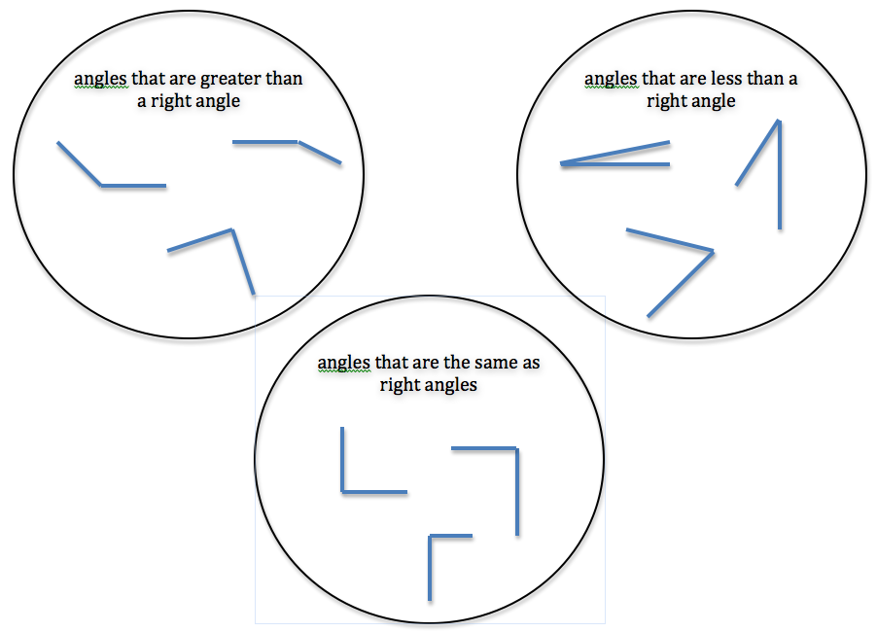  Solution: There is a right angle in the circle with angles that are greather than a right angle.  Possible reasons: A right angle is like the corner of a piece of paper. These 2 (pointing to the first circle) are bigger than that, but this one (pointing to the correct response) is just like the corner of a piece of paper. So, this one should have been in the third circle. (constructed response)
2.G.2 Compare polygons to determine whether they are or are not congruent. | 2.G.2.1 Classify polygons in three ways. (1). same size, same shape (congruent); (2). same size, different shape, and (3) different size, same shape.  2.G.2.2 Understand congruence in polygons with different orientations (proximity, position, directions and turns). | 2.G.2. Look at the figures below. Tell which shapes are congruent. Tell which shapes are the same shape but are different sizes.  A B C D  E F G H  Solutions: Figures D & F, and C & H are congruent. Figures B & E and A & F are same shapes but different sizes.  2.G.2.1 & 2 Look at each pair of shapes. Some are congruent, some are the same shape but different sizes, and some are different shapes. Decide how each partner in the pair relates to the other (congruent, same shape different size, different shapes).  Solutions: congruent same shape, different sizes  congruent different shapes

2nd Grade Measurement
Mathematical language and symbols that students use and should understand at this grade level:
Measure, unit, length, weight, capacity, area, compare, more, less, most, more, least, equivalent units, height, width, distance, gap, overlap, personal benchmarks, money collections, analog clock, digital clock, o’clock, half hour, half past, am/pm,
Essential Standards | Clarifying Objectives | Assessment Prototypes
2.M.1 Understand the use of non-standard units in measurement of length, weight*, capacity and area.  *More properly mass, but most commonly operational as weight at this grade band. | 2.M.1.1 Compare objects with respect to their lengths, weights, or capacities using non-standard units.  2.M.1.2 Understand that larger units can be subdivided into equivalent units (partition).  2.M.1.3 Understand that the same unit can be repeated to determine the measure (iteration).  2.M.1.4 Understand the relationship between the size of a unit and the number of units needed (compensatory principal).  2.M.1.5 Understand the measuring of two-dimensional space (area) using non-standard units. | 2.M.1.1 Materials: string, 3x3 sticky notes, paper  Work with a partner and cut a piece of string that measures the distance from the tip of your longest finger to your elbow. Find two things in the room that are longer than the piece of string, and two things that are shorter than the piece of string. Find one thing that is about the same length as your string. Use five post-it notes, and draw a picture and write the name of each item you find. On your paper put the post it notes showing the items you measured from smallest to largest.  (performance task)  2.M.1.2 Materials: worksheet with three pencils on it.  Directions: Samantha used this pencil to measure the top of her desk. When she got to the end of the length, there was a little bit more, but not enough for a whole other pencil. Show two ways you could divide the pencil to use smaller pieces to measure.  Solution: Students should be able to show a pencil divided in equal sized pieces, halves, fourths, etc. (constructed response)  2.M.1.3 What do you have to do when measuring the length of the classroom with pencils? You may draw a picture and write your answer in words.  Solution: You have to put the pencils end-to-end where they are touching but not overlapping. If you run out of pencils and you still have more to measure, you can take one and make a mark where it ended, pick it up and put it down again where the mark is to not leave any gaps or overlaps. (constructed response)  2.M.1.3 Materials: three to five large plastic jars (quart size to gallon size, more or less) and a plastic cup (about an 6-8 oz. size).  Put these jars in order starting with the one you think holds the least amount of water, to the one that holds the most water. How could we use this cup to check your prediction?  Solution: student needs to be able to give a plausible response that includes “no spills” (gaps) and something about not overflowing the container (overlaps). What do you do if there’s water still left in your cup and the jar is full? (referring back to 2.M.1.2)  2.M.1.4 Give student a teddy bear counter and a paper clip. Provide the student with a sheet that says: It takes ten teddy bear counters to weigh a pair of scissors. Will it take more or less paperclips to weigh the scissors? How do you know?  Solution: Students should answer that there should take more paperclips to measure the scissors because the paper clips weigh less than the teddy bear counter. (constructed response)  2.M.1.5 Materials: A sheet of paper/mat with a rectangle on it that can be covered completely with square color tiles, cubes, teddy bears, or two color counters. Ask the student to choose a manipulative that would be best for covering the rectangle. Once they have made their choice, have them actually cover the rectangle with the units and tell you how many units it took.  Solution: Students should use the cubes to completely cover the rectangle with no gaps or overlaps. They should be able to correctly count the tiles and report the number of tiles it took. (performance task)
2.M.2 Use analog and digital clocks to tell time to the hour and half hour. | 2.M.2.1 Understand a.m. and p.m. | 2.M.2 & 2.M.2.1 Draw the hands on the clock below to show the same time as this digital clock. What would you be doing at this time if it were a.m.? What would you be doing if it were p.m.? (constructed response)  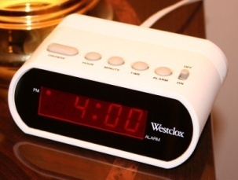  Solution:  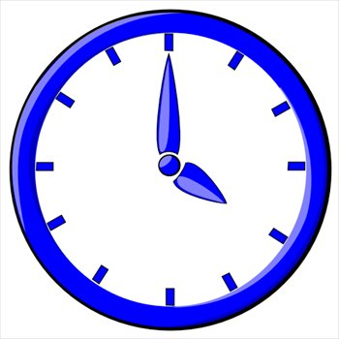 Solution: At 4:00 a.m. I am sleeping, and at 4:00 p.m. I am just getting home from school.  (constructed response)
2.M.3 Use strategies to count money collections up to one dollar ($1). | 2.M.3.1 Remember the names and values of coins (penny, nickel, dime, quarter).  2.M.3.2 Use the symbols $ and ¢ properly. | 2.M.3 and 1 & 2 What are two ways you can count these coins to find the value?  Possible Solutions:  Method 1: quarters first, 25, 50, dimes, 60, 70, nickels, 75, 80, pennies, 81 and 82¢ or $0.82.  Method 2: combine the quarters with the nickels to make 30 ¢ each, 30, 60, dimes, 70, 80, pennies, 81, 82¢.  Method 3: the quarters together are 5 tens, the two nickels are another ten, and there’s two dimes. So, there’s 8 tens, and 2 ones, 82¢. (constructed response)  2.M.2.1 & 2 Show two collections that both are worth 56¢.  Possible collection #1  Possible collection #2  Can you make this collection not using any pennies? Can you make it using only five coins in the collection? Can you make it with more than 10 coins? (constructed response)

2nd Grade Statistics and Probability
Mathematical language and symbols that students use and should understand at this grade level:
Graph, Venn diagram, line plot, horizontal, vertical, data, title, clumps, gaps, trends,
Essential Standards | Clarifying Objectives | Assessment Prototypes
2.S.1 Understand data from statistical investigations in order to develop and evaluate inferences and predictions. | 2.S.1.1 Analyze parts of data and the set of data as a whole to determine what the data show in Venn diagrams (2 circle) and line plots.  2.S.1.2 Use counting concepts of grouping and comparing to illustrate the differences between values and frequencies in line plots.  2.S.1.3 Identify patterns and trends to make decisions using data. | Pose a question. Collect the data. Analyze the data. Interpret the data.  2.S.1 A group of first graders made this Venn diagram about their class, but they forgot to finish it. Look at the diagram, what information could it be telling you about their class?  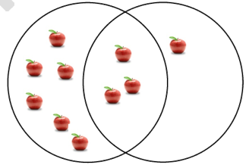  Possible solutions: Which do kids like better- apples or applesauce or both? What is your favorite flavor of ice cream-chocolate or vanilla or both? What is your favorite pet- dogs or cats or both? etc.  What kind of information is missing that would help you understand their class better?  Solution: missing information includes labels for the circles, what the apple represents, and a title. (constructed response)  2.S.1.1 What information does this Venn Diagram tell you about bugs?  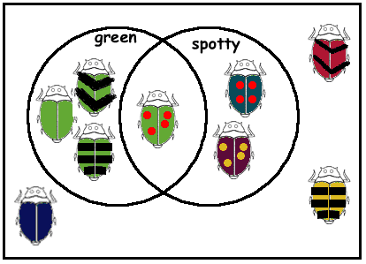  Possible responses: “Bugs that are green went in one circle, bugs that are spotty went in the other circle, and the bugs that are both green and spotty went in the middle because it had both attributes.” Or “These bugs didn’t go in the circle because they weren’t green and they didn’t have spots.”  (constructed response)  2.S.1.2 A second grade class surveyed all the students to find out how many pockets they had on their clothes that they were wearing. They made this line plot:  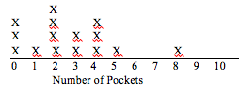  The person with the most pockets had how many? 8 pockets  The most number of people had how many pockets? 2 pockets  How many people are here today? fifteen  What’s going on with 6 and 7? What does it mean that there’s no x’s? There were no people that had six pockets or seven pockets.  If we got a new student today, what would you guess about how many pockets he or she had ? two, zero or four would be justifiable answer choices. (constructed response)  2.S.1.3 If you opened a mini-bag of M&Ms, about how many M&Ms would be in your bag? Why do you think so?  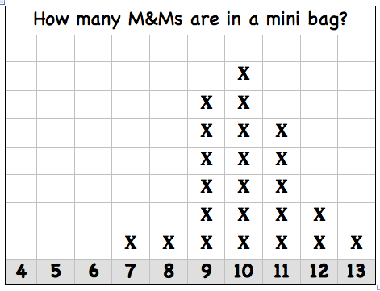  Possible responses: “I would probably get 10 M&Ms. This is what 7 people got when they opened their bags.” Or “I would probably get 9, 10, or 11 M&Ms because 18 of the 23 bags opened had that much in them.” “I would get more than 7 M&Ms in my bag because noone got less than 7 M&Ms when they opened their bags and no more than 13 since noone got more than that.” (constructed response)

